APA (American Psychological Association) Referencing Style
This guide provides information on using the APA method of acknowledging (or citing) sources of information for assessment tasks.
It is also available as a chapter in The ACU study guide. It is based on the Publication manual of the American Psychological Association (5th ed.).
This guide explains:
- The main points about APA referencing
- How to cite a source in your work
- How to format sources: selected examples
- How to construct a reference list

THE MAIN POINTS ABOUT APA REFERENCING
The APA referencing system consists of two parts
In text citations: | These citations identify the author and publication date of the ideas used in your assignment. Citations are usually placed at the beginning or end of sentences within paragraphs.
Reference list: | The list of all sources cited in the assignment is provided on a separate page at the end of the assignment. The list (titled References) is in alphabetical order and contains complete publication details for all of the sources.

Citations
There are two main types of citations
Direct quote: | Ideas that are copied exactly from another writer’s work. It includes the exact words and sentence structure as the original author’s work.
Paraphrase: | Ideas taken from another writer. The student summarises and expresses in his/her own words the ideas of another writer. This is much more common in academic work.

HOW TO CITE A SOURCE IN YOUR WORK
The APA referencing system provides the author's surname, date, and page number for a direct quote; and the author's surname and date for a paraphrase.
When citing the same source within the same paragraph
First citation: the author's surname and date of publication
Subsequent citations: author's surname only
Brooks (2000) maintains that adults influence an adolescent's spiritual and emotional development. Parents, grandparents, teachers, for example, play a major role in shaping an adolescent's behaviour (Brooks).[Students, please note this is not a complete paragraph]
There are various ways to cite a source; some examples are listed below.

How to Include a Direct Quote:
When you provide a direct quotation, place the quote within "quotation marks" and acknowledge the author's surname, date of publication, and page number(s).
Brooks (2000) stated, "Both biological and environmental factors jointly influence an individual's personality development" (p. 28).
Recent research shows that "children who are read to at home have a greater awareness of language and text" (Smith, 2001, p. 24).
When the direct quote extends over two pages, list the page on which the quote starts and the page on which it ends.
Brooks (2000) stated, "Both biological and environmental factors influence an individual's personality development. These influences raise questions about factors that affect human behaviour" (pp. 28-29).
When a direct quote is more than 40 words, indent the quote five to seven spaces, leave out the "quotation marks" and single spacing may be used :
In adolescence, peer relationships contribute greatly to self-knowledge and self-evaluations. Peers provide social comparison information and social support. Egalitarian friendships featuring acceptance and trust enable individuals to disclose emotional experiences to others, which promotes inner dialogues and self-understanding. Boys and girls are differentially likely to experience such relationships. (Capara & Cervone, 2000, p. 204)

How to Include an Electronic Direct Quote
Professionally printed copy:
When you cite from an electronic document that is exactly the same (e.g., same layout, text & page numbering) as the professionally printed copy, identify the author, date of publication, and page number.
Although the students "were determined to do well, this determination was very vulnerable" (Page, Farrington, & DiGregorio, 1999, p. 6).
Non-professionally printed copy:
When you cite from an electronic document that is different (e.g., different text, layout, page numbering) from the professionally printed copy, identify the author, date of publication, and paragraph number. An article or a report or may include a section title and its number:
"The government regards higher education as contributing to the attainment of individual freedom, the advancement of knowledge and social progress" (DETYA, 2000, 1.1.2 Purposes and objectives, para. 1).

How to Include a Paraphrase:
When you use the author's ideas but not his/her exact words, provide the author's surname and date of publication.
One Author
Biological and environmental factors influence human development (Brooks, 2000).
Brooks (2000) observed that human development is influenced by biological and environmental factors.
Two or More Authors
Human development is a complex issue (Brooks, Adams, & Clarke, 1999).
Green and Brooks (2001) noted that human development is a complex issue.
Several Sources
Research shows that human development is a complex and multifaceted issue (Brooks, Adams, & Clarke, 1999; Green & Brooks, 2000; Harvey, Smith, Brooks, & Adams, 1998).
Six or More Authors/Using et al. (" et al." means "and others")
If there are six or more joint authors, in first and subsequent citations cite the first author followed by et al.
First and subsequent citations:
Adams et al. (1994) state …
It was further observed that this influence extends to those outside the local community (Adams et al., 1994).
Using 'et al.'
If there are three to five authors, cite all of the authors followed by the publication date for the first citation and on subsequent citations you use et al.
Human development is a complex issue (Brooks, Adams, & Clarke, 1999).
Moreover, a variety of influences, including biological and environmental influences, add to the complexity of individual development and behaviour (Brooks et al., 1999).
A Secondary Source-An Author Cited by Another Author
If you are reading a text that discusses another person's work, cite the surname of the person whose work was mentioned and then cite the surname of the author you are reading.
Bank (as cited in Jepp, 1991) noted that learning is a lifelong experience.
Learning is a lifelong experience (Bank, as cited in Jepp, 1991).
This tells the reader that you found out about Bank's work by reading Jepp's article. In the reference list you provide an entry for Jepp.
Two or More Works from the Same Author
When an author has written two or more pieces of work in the same year, distinguish each piece of work by sorting the titles of each book/article alphabetically and then identifying them as:
(Clarke, 2000a) | (Clarke, 2000b) | (Clarke, 2000c)
(Brooks, Adams, & Bond, 2001a)
(Brooks, Adams, & Bond, 2001b)

Authors With the Same Surname
When two authors have the same surname, use their initials to distinguish them:
S. Clarke (1999) and J. Clarke (1999) observed several differences in adolescent behaviour.
Research conducted by D. Brown confirms P. Brown's initial findings that peers influence adolescent behaviour (Harvey & Thomas, 1998).
Corporate Author
When an organisation or a group is the author:
First citation: | (National Institute of Health [NIH], 1998)
Subsequent citations: | (NIH, 1998)

Newspaper Article/Journal Article With No Author
When there is no author, cite the article title in quotation marks:
("South Australian premier resigns in tears," 1999)
Book No Author
When there is no author, cite the title of the book in italics and the publication date:
(Science and Mythology, 1932)
Anonymous Author
Only use anonymous when it appears on the publication:
(Anonymous, 1963)
No Date
When a work has no publication date put (n.d.) "no date", cite the author followed by the abbreviation for no date:
Clarke (n.d.) studied secondary students' classroom behaviour.

Statutes: Acts of Parliament
When citing an act of parliament give the name of the act and the year of the act as they appear in the title. No author is required.
Employee Relations Act 1992
Personal Communication
When you cite personal communication (e.g., conversations, interview data, lecture notes), cite the communicator's initial and surname, a title to explain the type of communication and the date of communication:
M. Carmody (personal communication, July 30, 2001) commented Â…
The nursing process requires an on-going commitment (A. Jones, personal communication, August 4, 1999).
There is no entry for 'personal communication' in the reference list

HOW TO FORMAT SOURCES: SELECTED EXAMPLES
Book  • One author  • Two to six authors  • More than six authors  • Edition other than the first edition  Report  • Authored report  • Organisation report  Article/Chapter  • Chapter or article in an edited book  • Chapter or article in an encyclopaedia  • Journal article  • Magazine article  • Newsletter article  • Newspaper article  • Conference proceedings  Brochure  Audiovisual  • Cassette recording | • Cassette recording: individual tape from a series  • CD Rom  • Email, Interviews and Telephone Conversations  • Video Recording  Personal Communication  Electronic Sources  • Abstract from an Electronic Database  • Electronic Journal Article  • Electronic Report  • Electronic Conference Proceedings  • ERIC Document  Variations  • Author and Publisher are the same  • Corporate Author  • Same Author with Several Publications in the One Year  • Same Author with Different Year Publications  • No Date  • No Author

For the list of References, the APA referencing system follows the:
Author. Date of publication. Title. Publisher details format for books and reports.
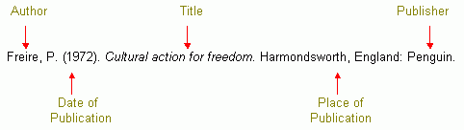
Author. Date of publication. Title. Journal Name, Volume(Issue). Page numbers format for journals.
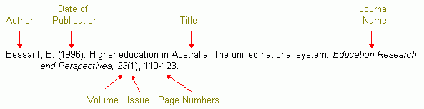

Book
One Author
Two to Six Authors
More Than Six Authors
Edition Other Than the First Edition
Report
Authored Report
Organisation Report
Article
Chapter or Article in an Edited Book
Chapter or Article in an Encyclopaedia

Journal Article
Volume and Issue Number
Volume but No Issue Number

Magazine Article
Author Known
Author Unknown

Newsletter article
Author Unknown

Newspaper Article
Author Known
Author Unknown

Conference Proceedings
Published
Unpublished

Statutes: Acts of Parliament
With a number
Without a number

Brochure

Audiovisual
Cassette Recording
Cassette Recording: Individual Tape From a Series
CD Rom

Email, Interviews and Telephone Conversations
See: Personal Communication
Video Recording

Personal Communication (e.g., conversations, email, interviews)
Personal communications are not included in the reference list, because the information cited is not retrievable.
Electronic Sources
Internet sources (e.g., articles, journals, reports) are obtained on-line, and these documents are cited and referenced according to the -‘author-date’- format. If the reference was obtained from a database or a web site, the name of the database (e.g., ProQuest) or the website's URL address (e.g., www. ...) must be included.
Abstract from an Electronic Database
Electronic Journal Article
Electronic Report
Electronic Conference Proceedings
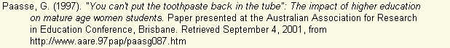
ERIC Document
For further information about referencing electronic resources see the APA web site.

Variations
Author and Publisher are the same
Corporate Author
Same Author With Several Publications in the One Year
List according to title and identify as 'a', 'b', or 'c'.
Same Author With Different Year Publications
List according to date
No Date
No Author

HOW TO CONSTRUCT A REFERENCE LIST
- A reference list starts on a new page and is headed References
- List all citation entries alphabetically according to author, or if there is no author list according to title
- Use the hanging indent format where the first line of a citation is not indented while the second and any
subsequent lines are indented five to seven spaces
- Single space within each citation entry in the list
- Double space between citation entries in the list
An Example of a Reference List
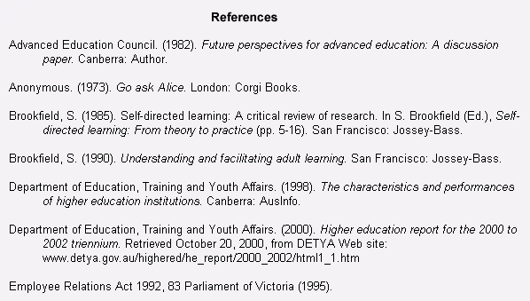
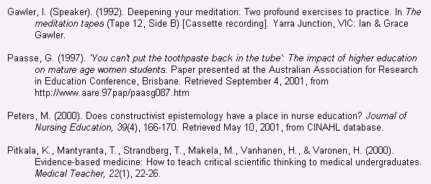
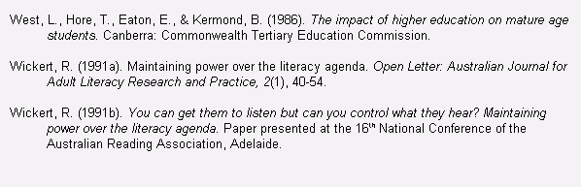
For further information refer to: Publication manual of the American Psychological Association (5th ed.) in your campus library.

The url for this page is:
http://my.acu.edu.au/node.cfm/30877A04-38D0-4377-A62766D134F1BEB5?type=student

Page content last updated 05-Jun-03
Page content last updated by: P BLAKEY
Copyright © Australian Catholic University 1998-2006.
ABN 15 050 192 660 CRICOS Reg: 00004G, 00112C, 00873F, 00885B

